**CASE STUDY**

**Website (OrangeHRM)**: https://opensource-demo.orangehrmlive.com/web/index.php/auth/login

**Objective:** To test the concepts of SDLC, Agile, Software Testing, DBMS and CI/CD pipeline.

**SDLC, Agile and Software Testing**

**VM Creation**

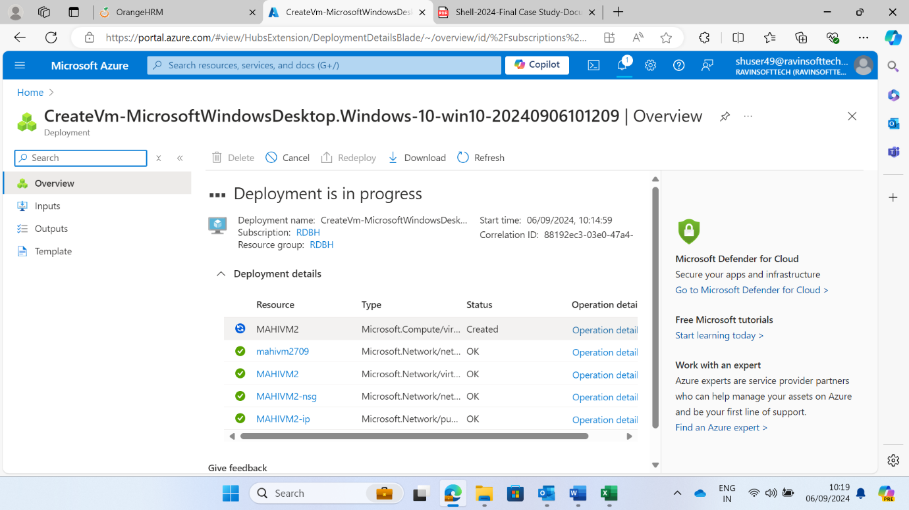

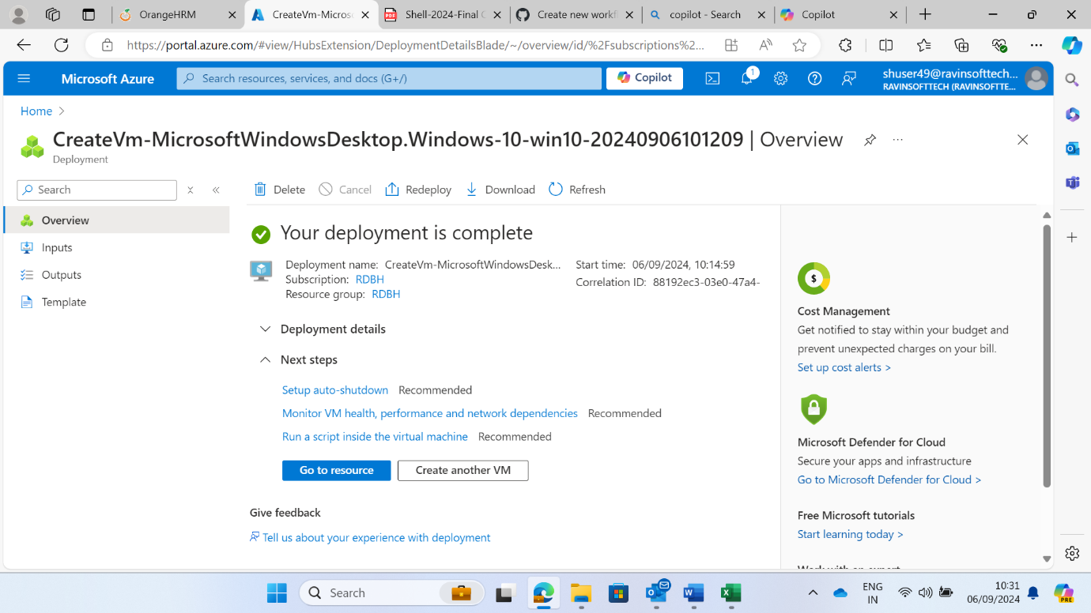

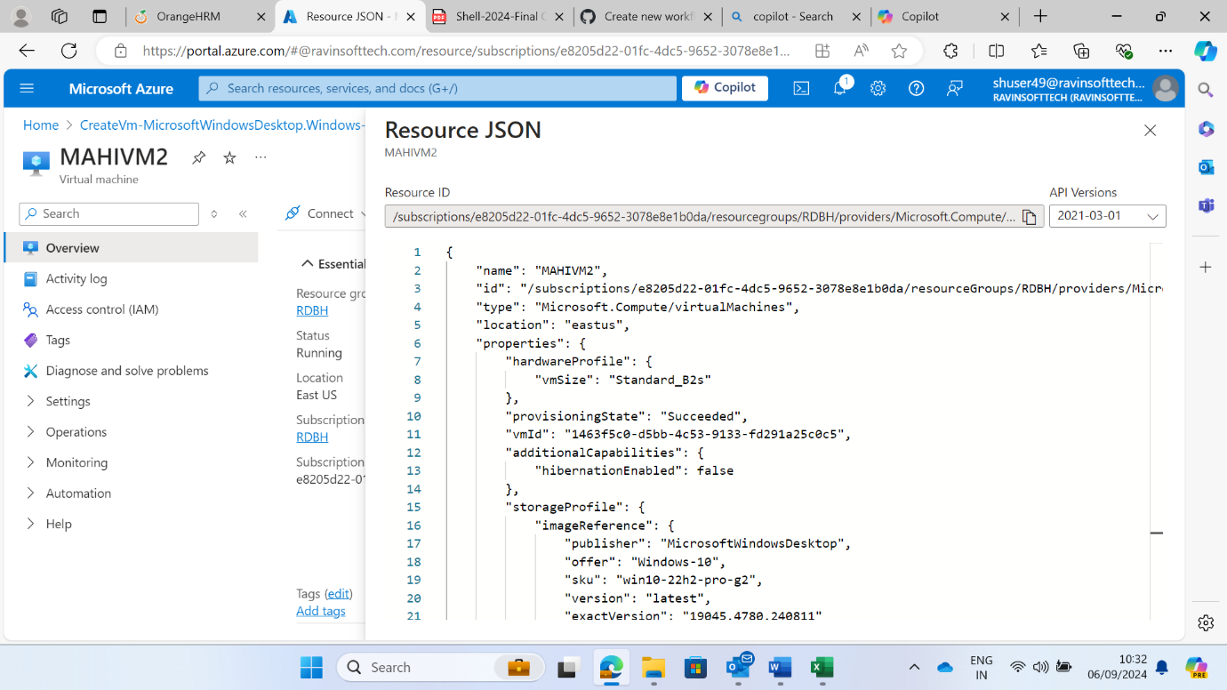

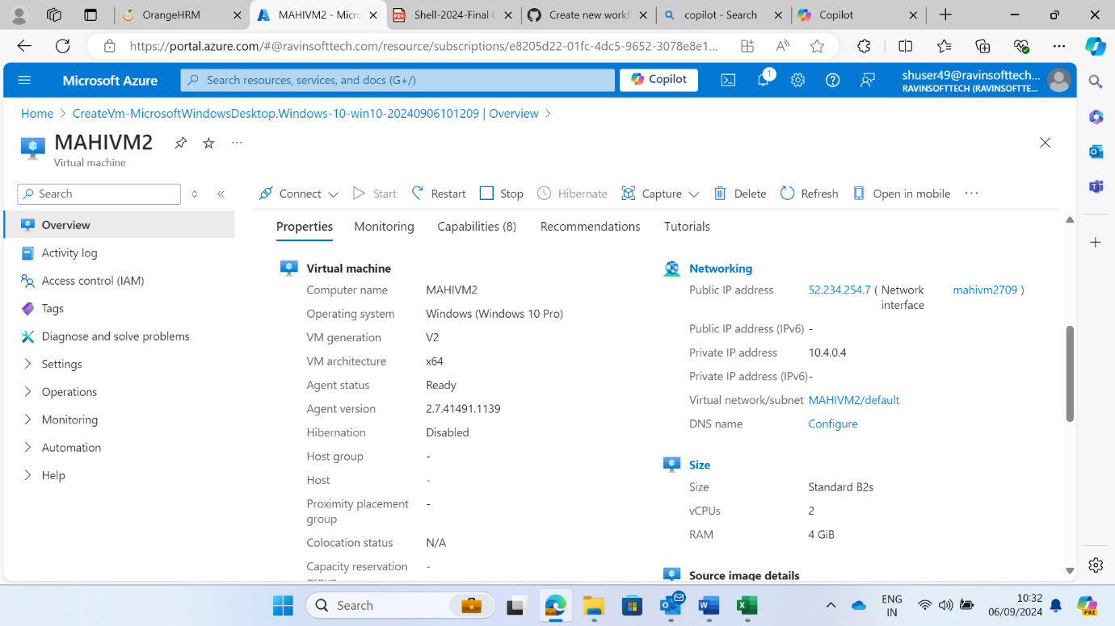

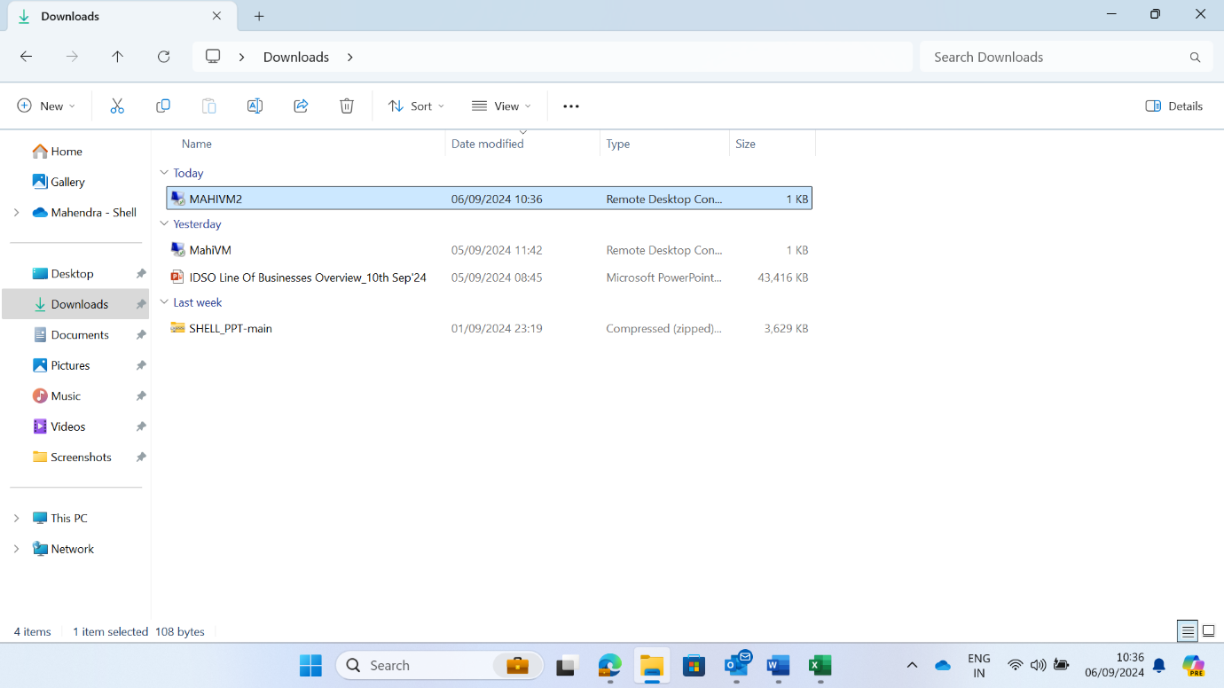

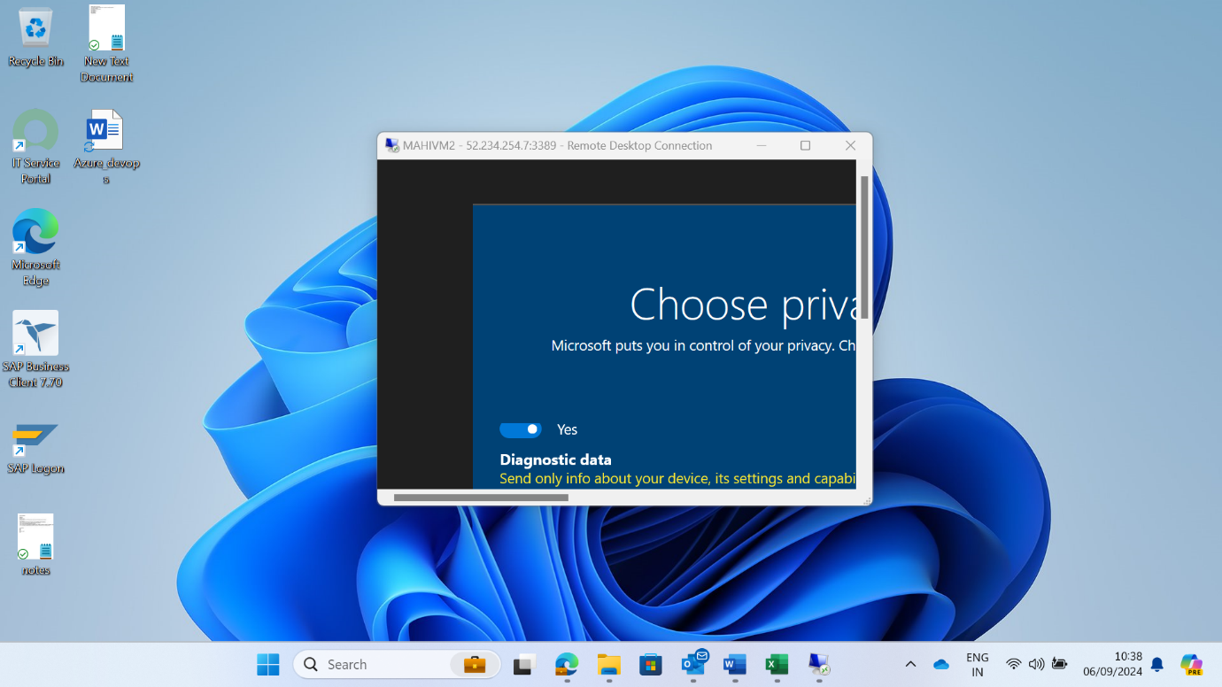

**DevOps project:**

1. **Test Cases**

their description, criteria, test steps, test, data, expected result, Actual Result and Status:

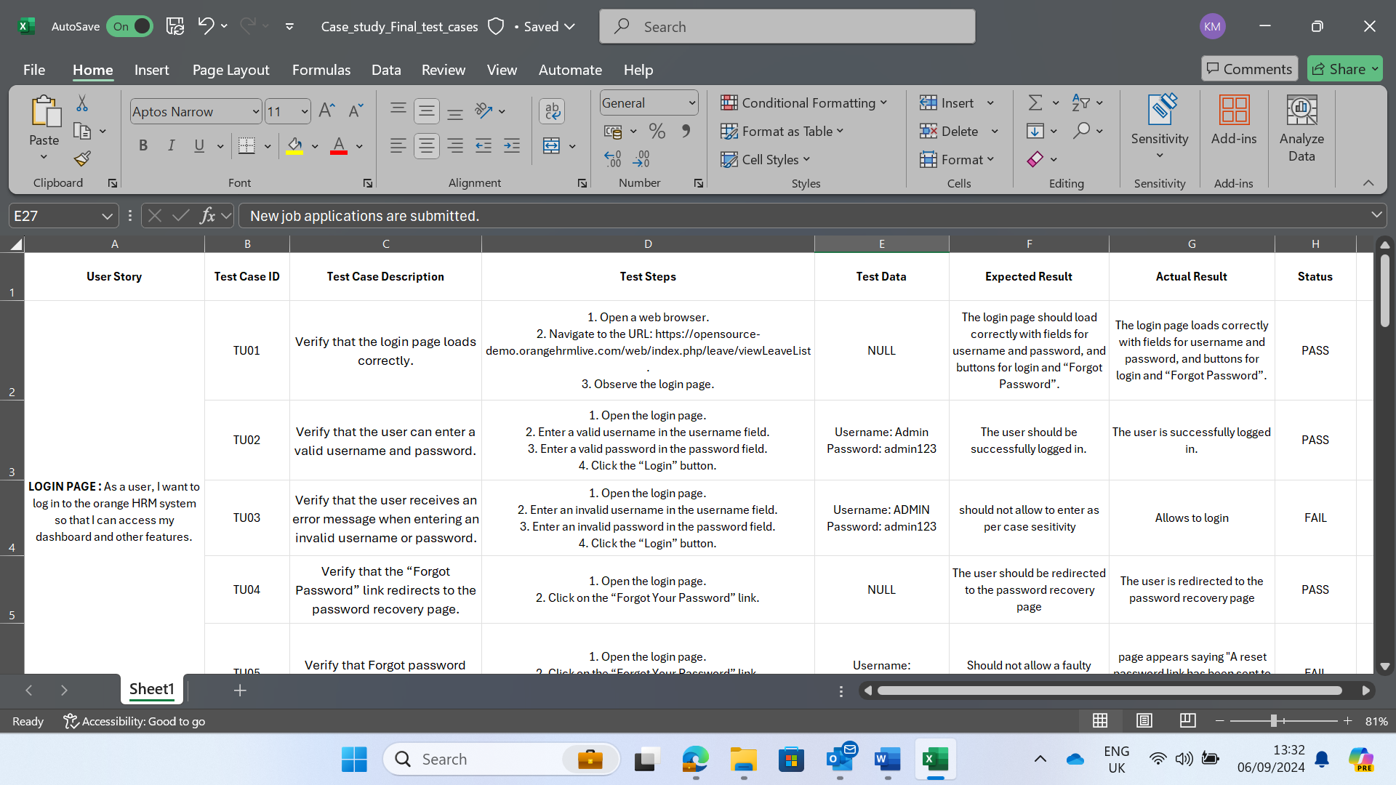

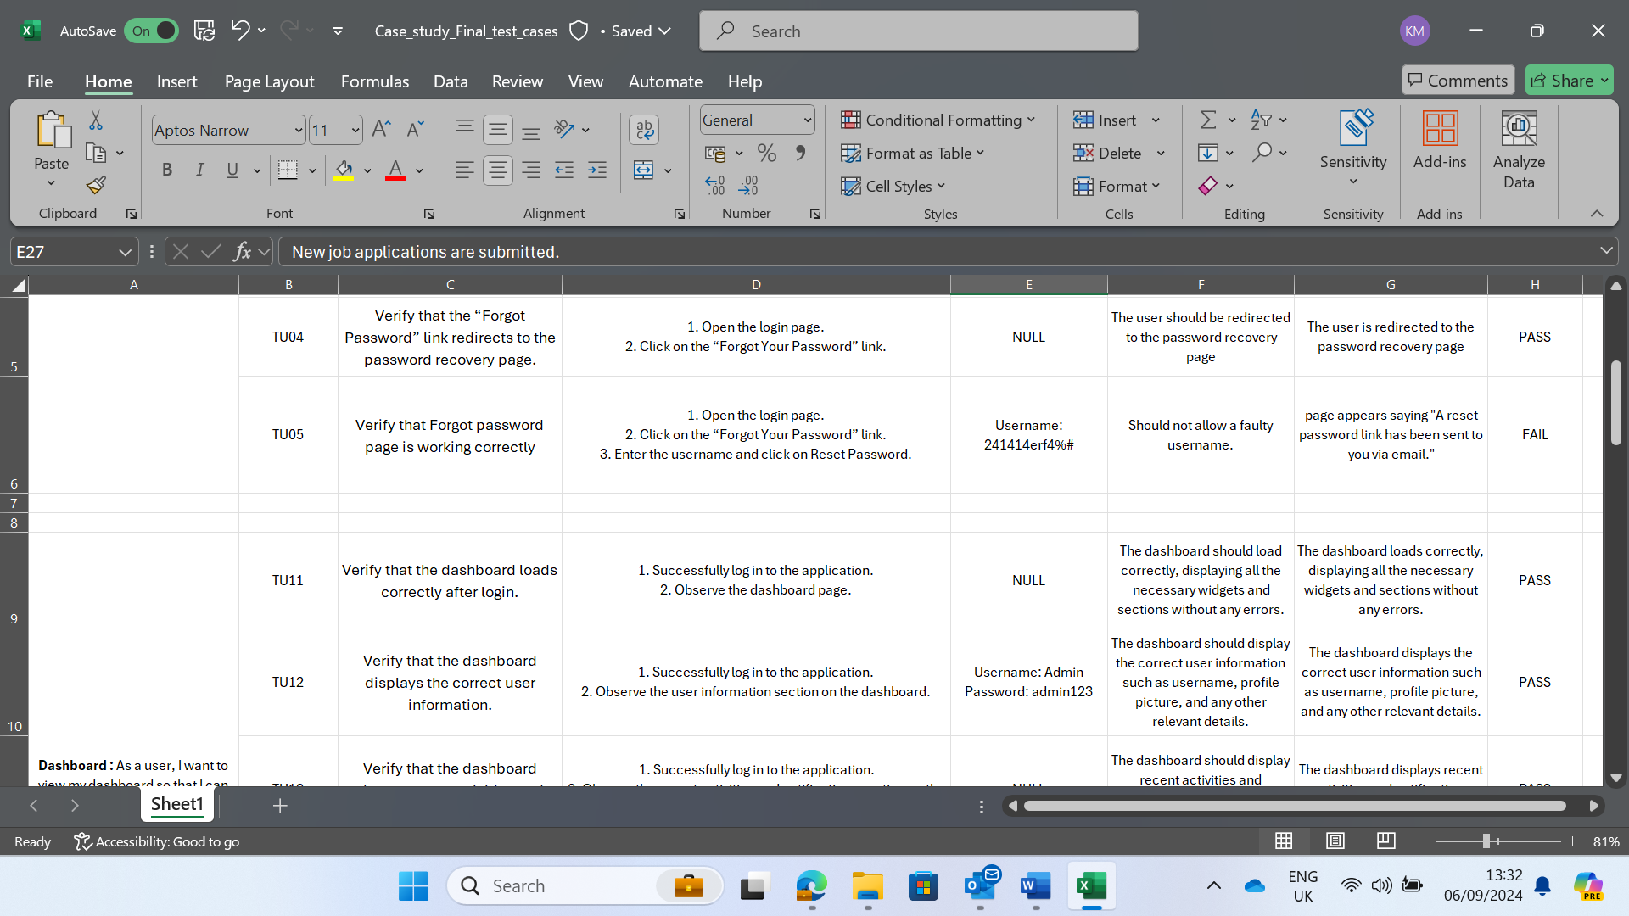

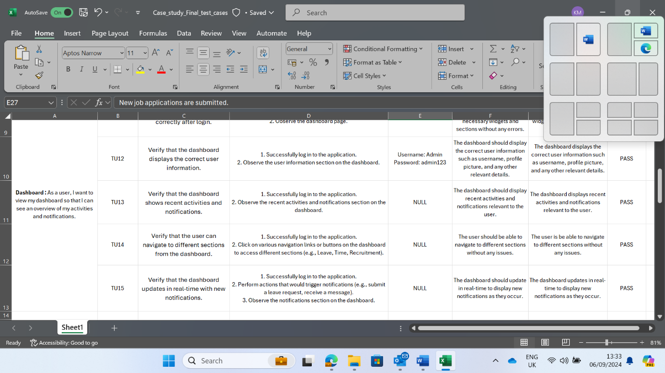

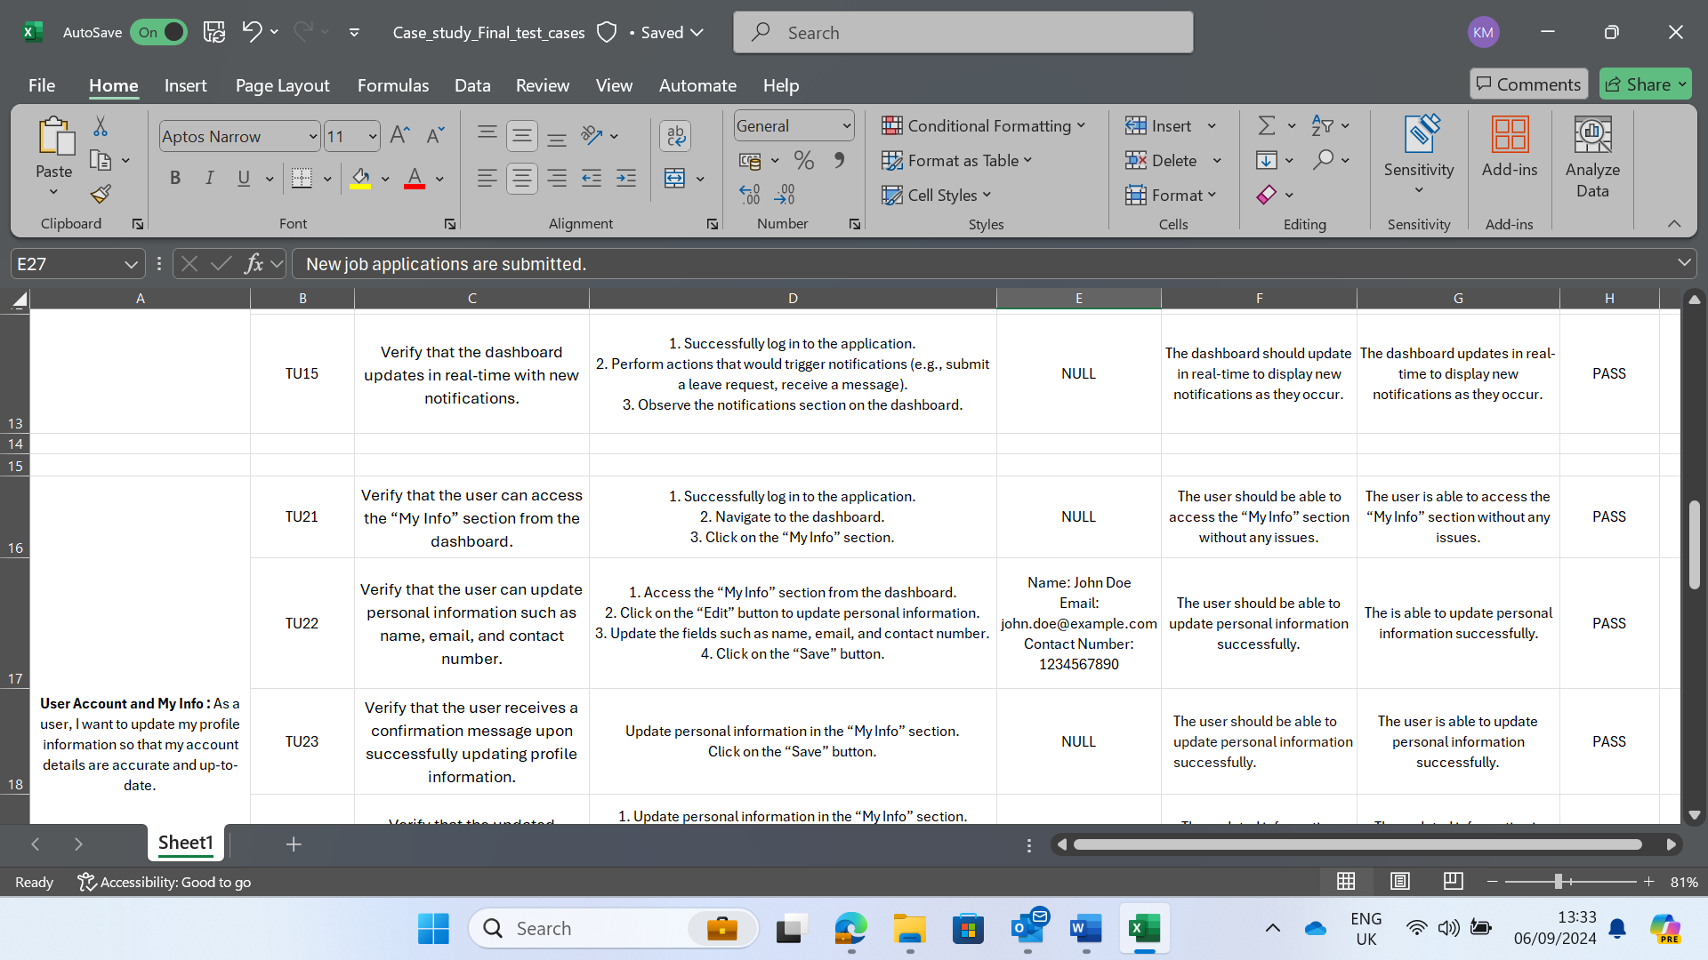

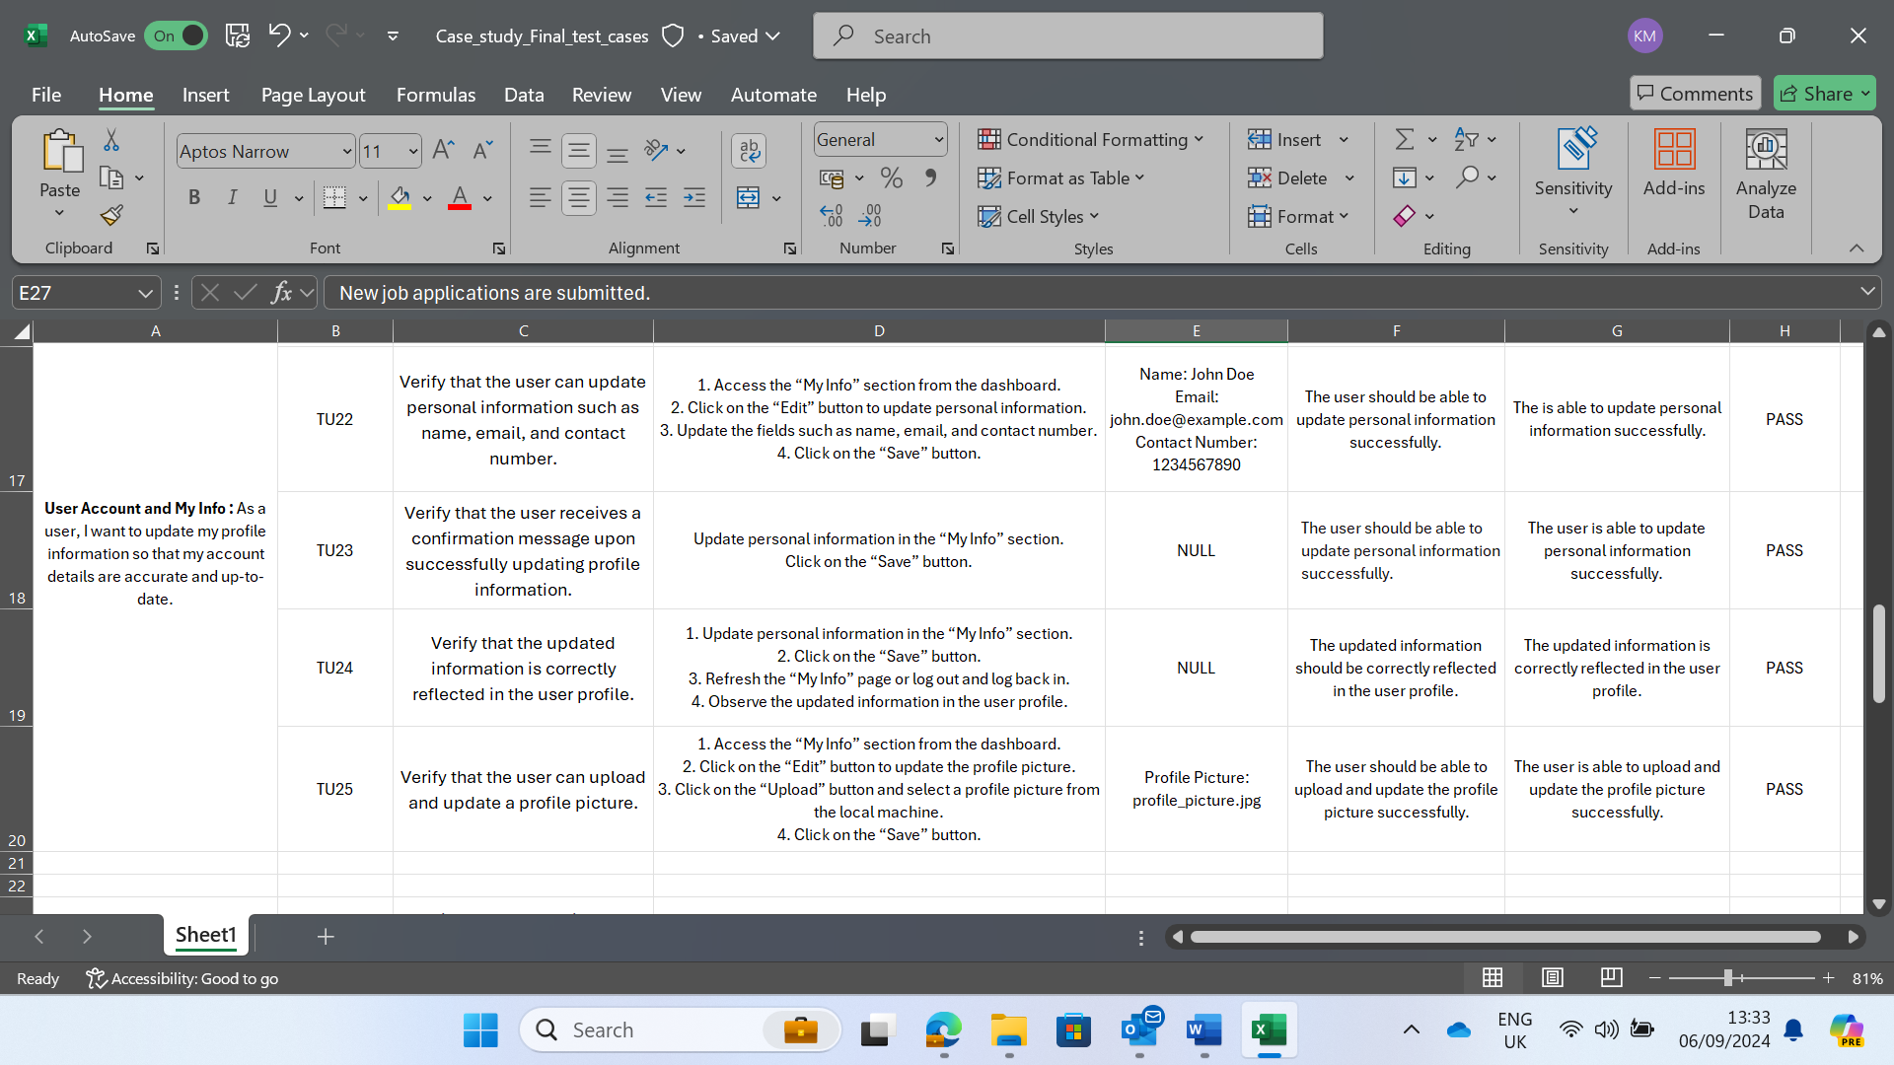

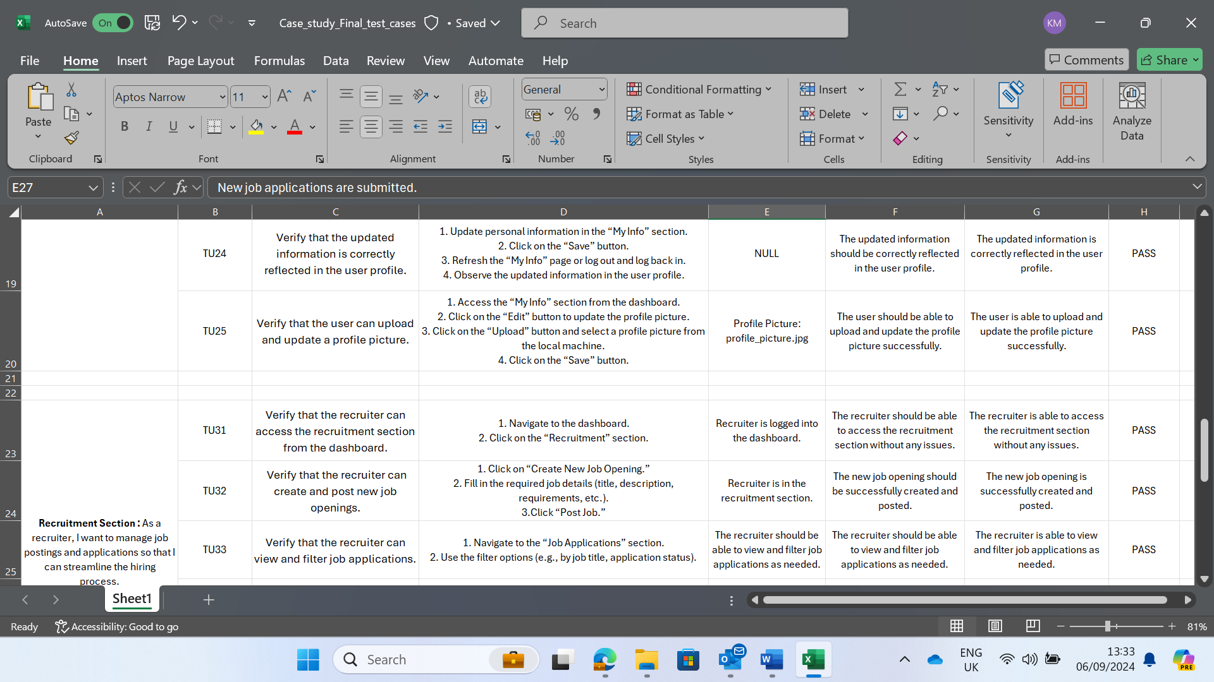

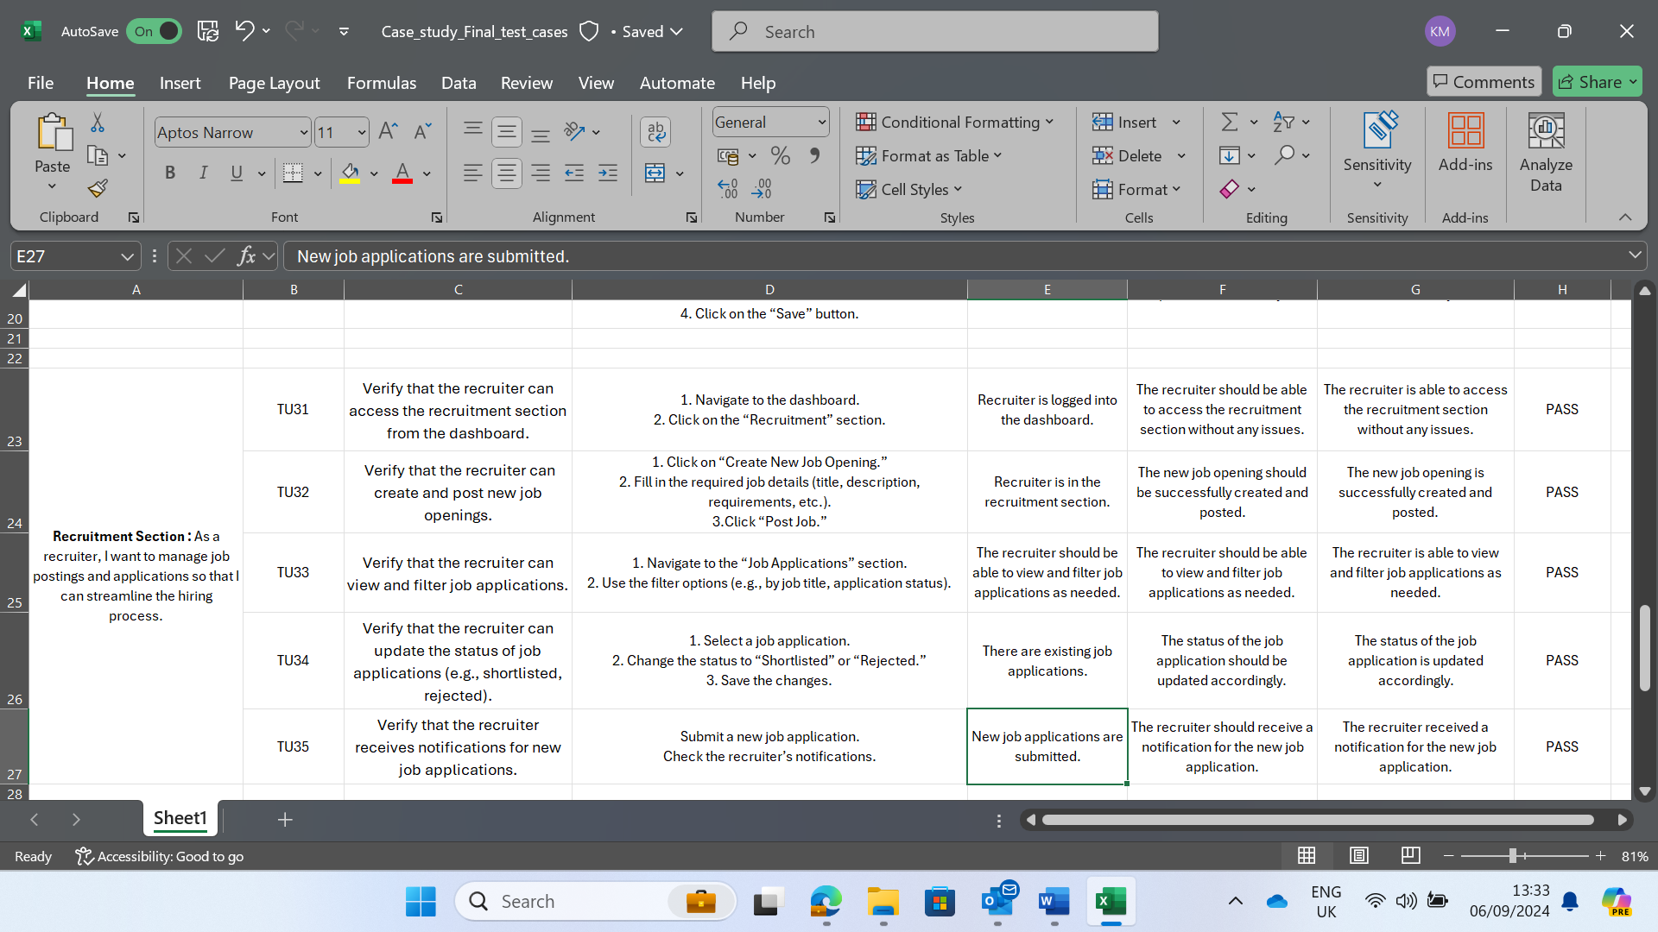

1. Tasks

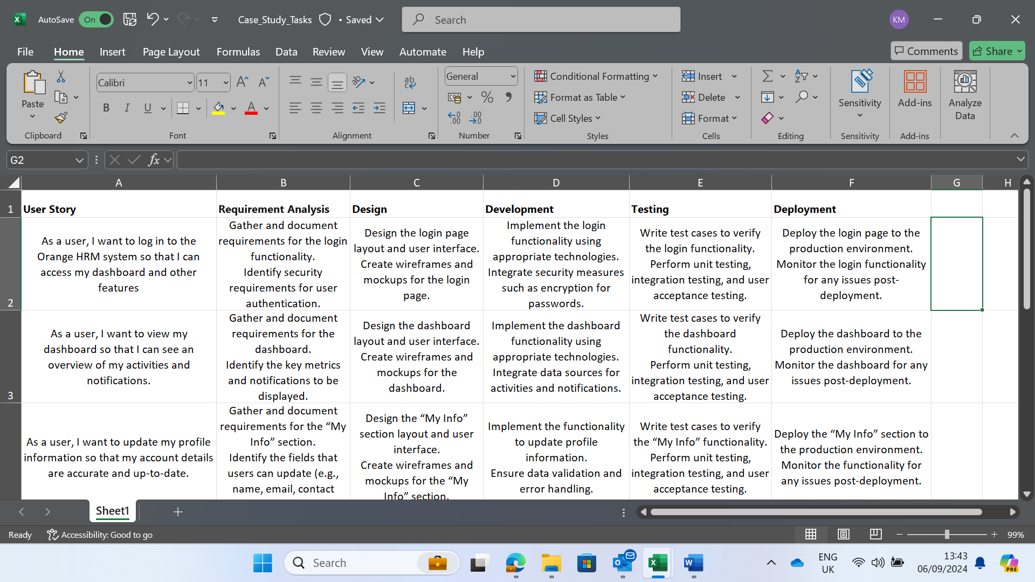

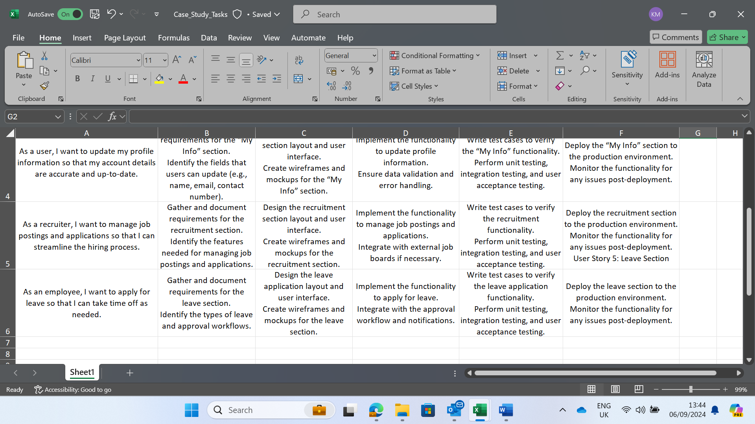

1. Defect Report

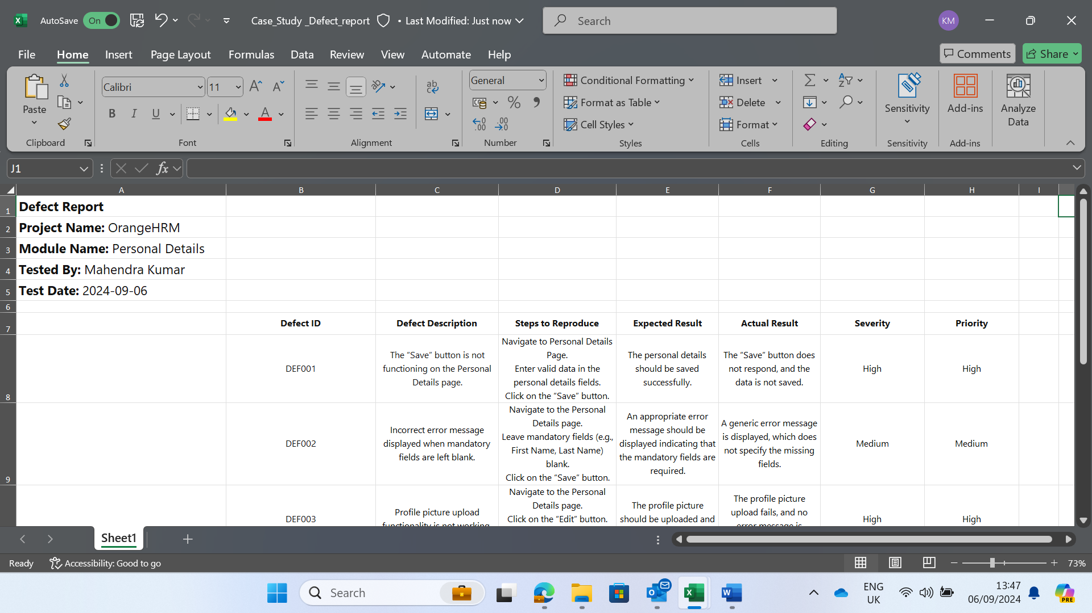

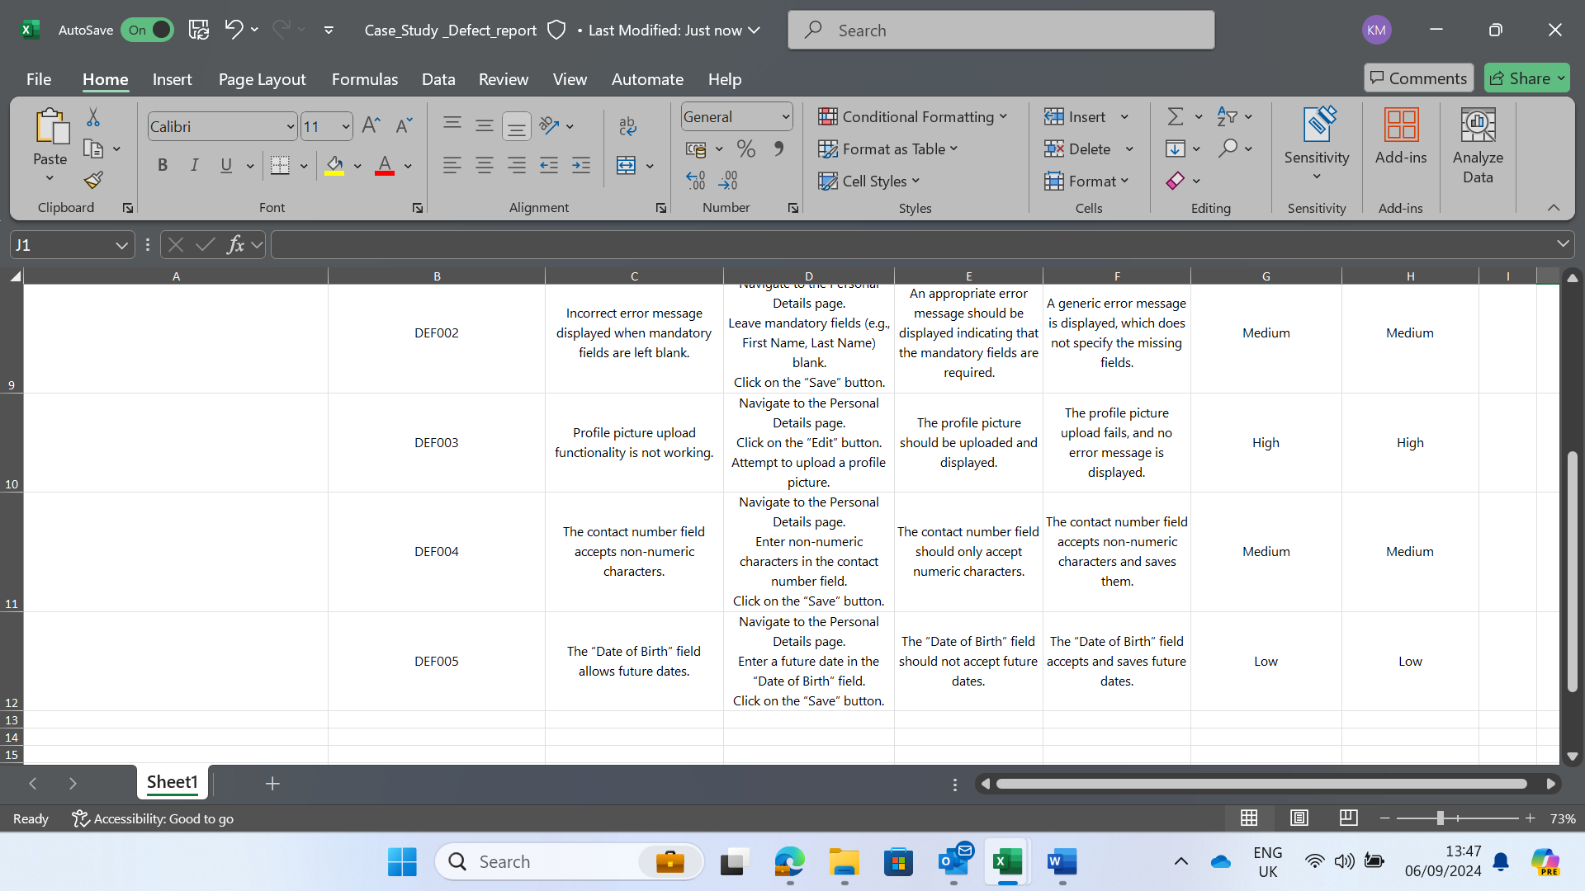

**Azure DevOps Project:**

Project Name: **Case_Study_Final_Testing**

Epics name: **Orange HRM**

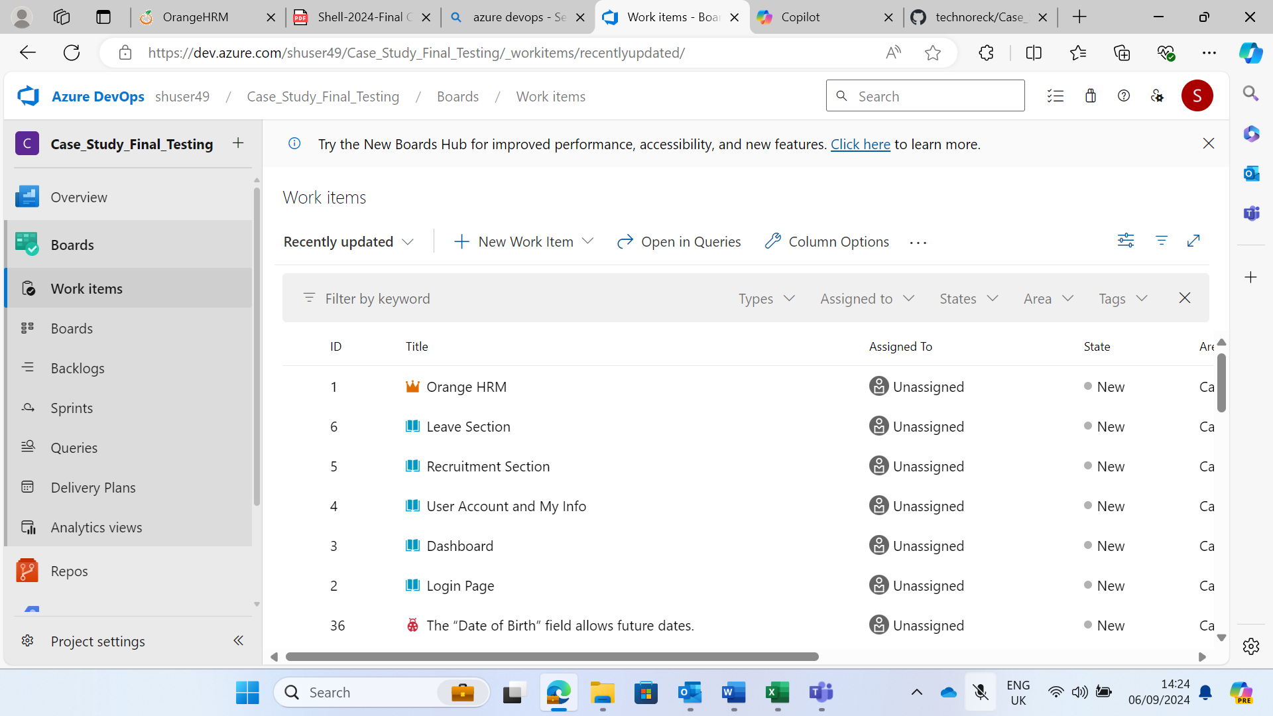

User story 1 : As a user, I want to log in to the orange HRM system so that I can access my dashboard and other features.

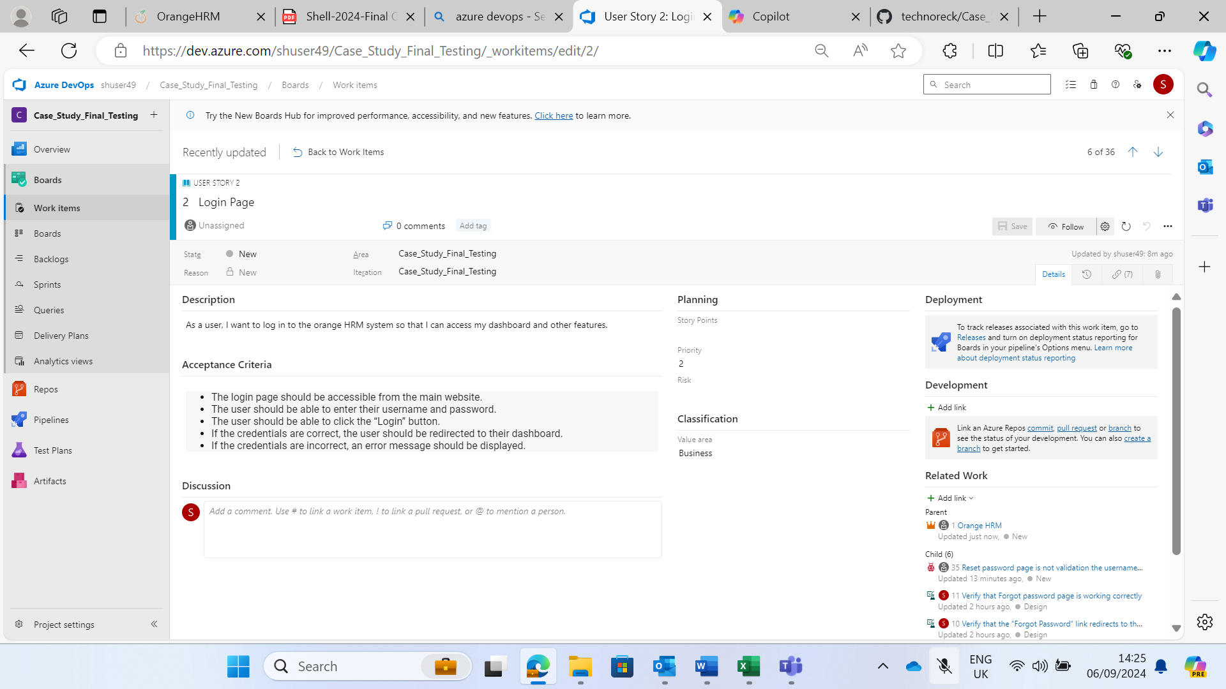

User story 2: As a user, I want to view my dashboard so that I can see an overview of my activities and notifications.

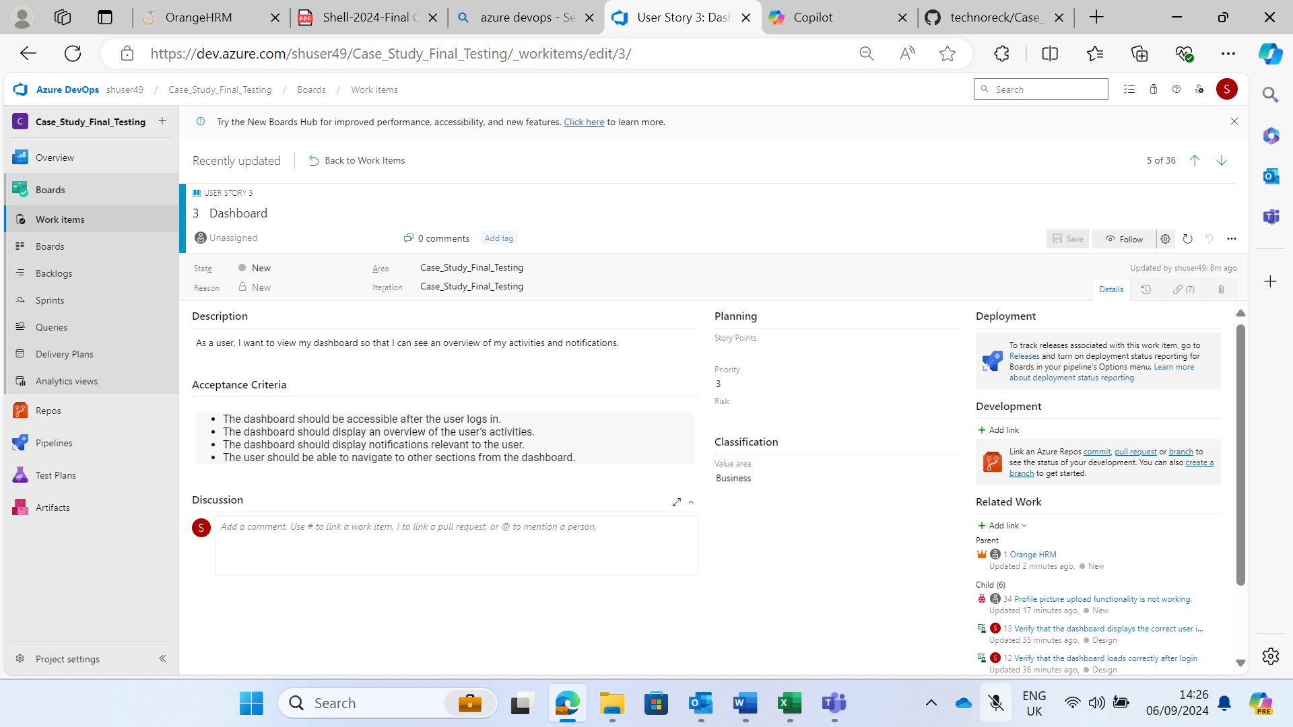

User story 3: As a user, I want to update my profile information so that my account details are accurate and up to date.

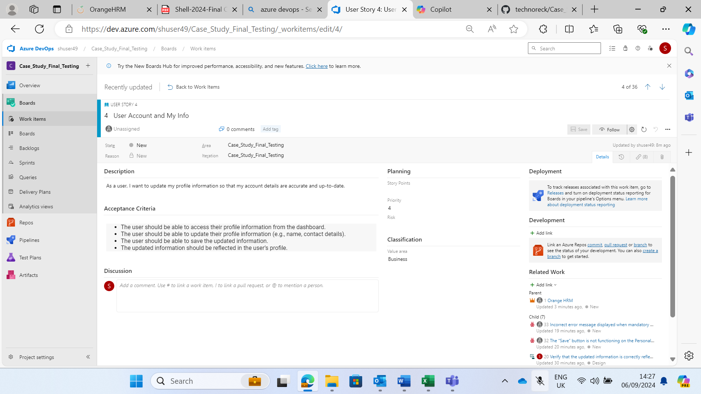

User story 4: As a recruiter, I want to manage job postings and applications so that I can streamline the hiring process.

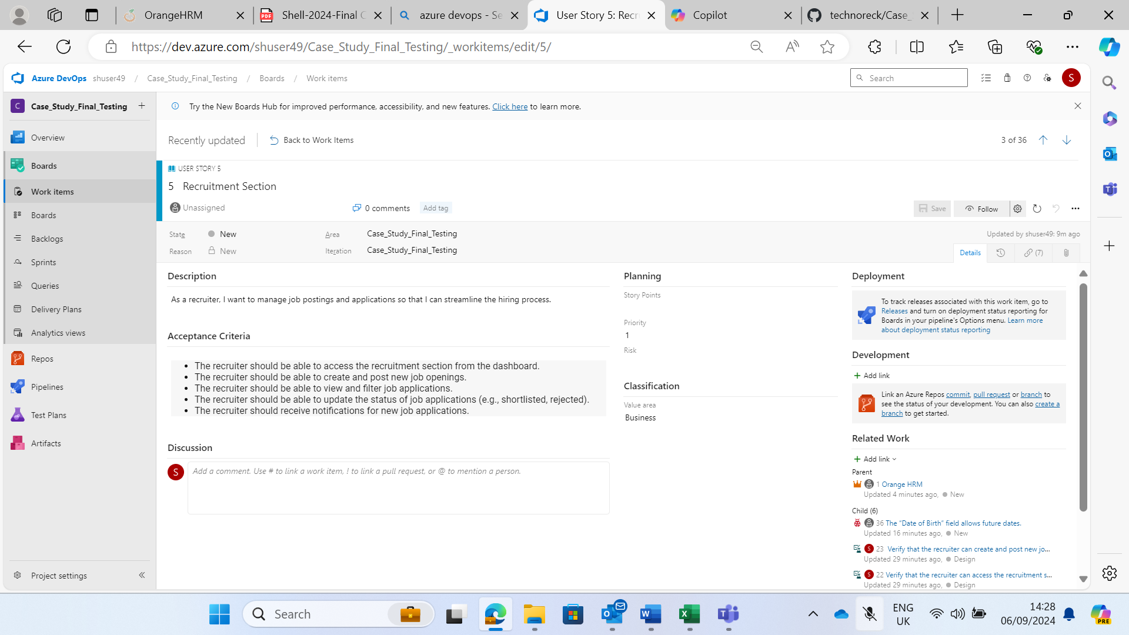

User story 5: As an employee, I want to apply for leave so that I can take time off as needed.

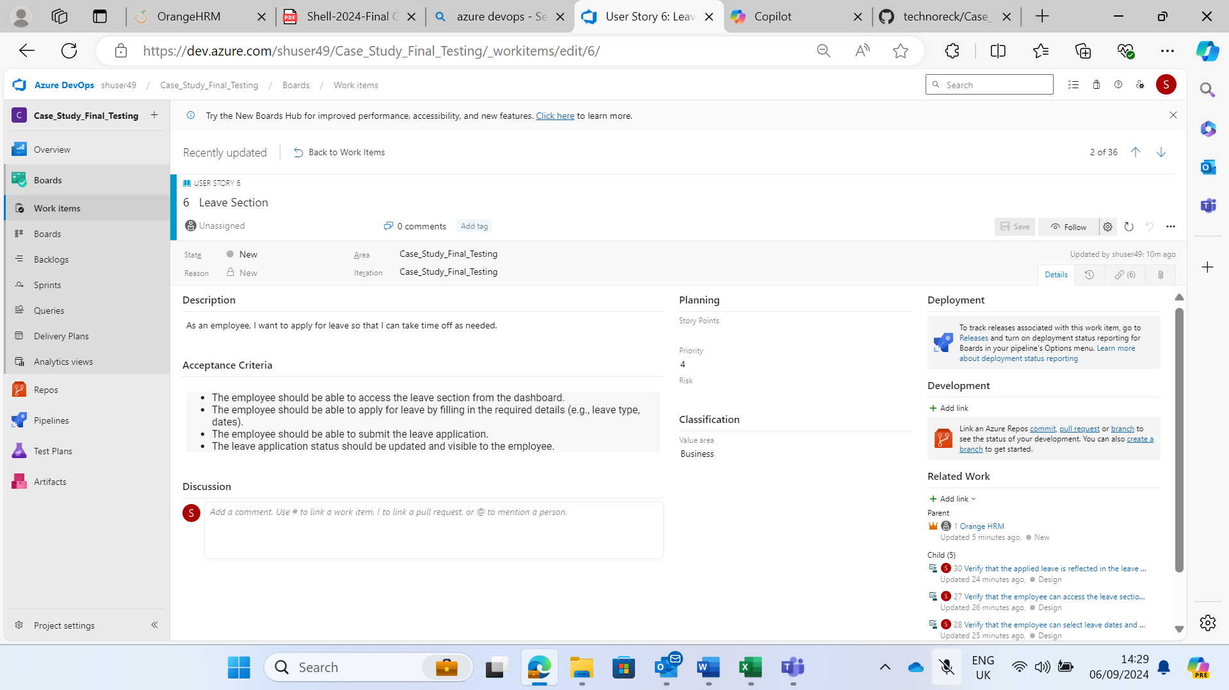

**Implementing the CI/CD Pipeline using GitHub Actions**

Created a repository Case_Study_GA

GitHub repository link : [technoreck/Case_Study_GA: Testing github actions and workflow](https://github.com/technoreck/Case_Study_GA)

1. Adding a python file test.py

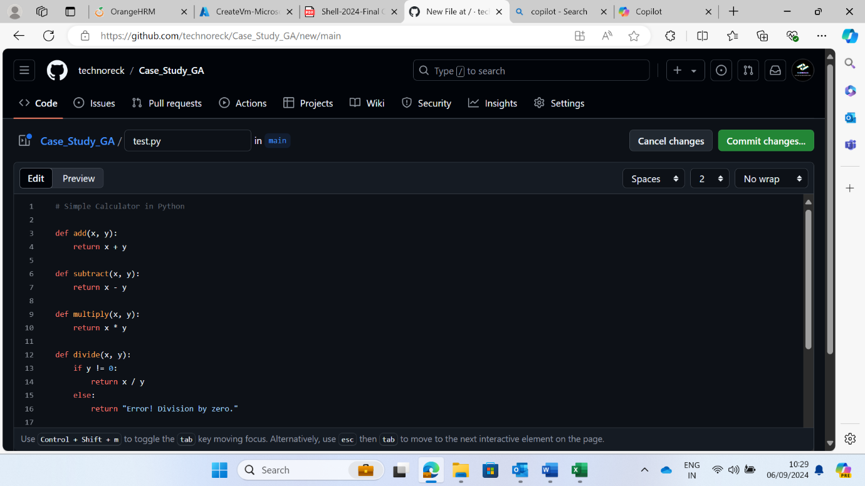

1. File created and pushed

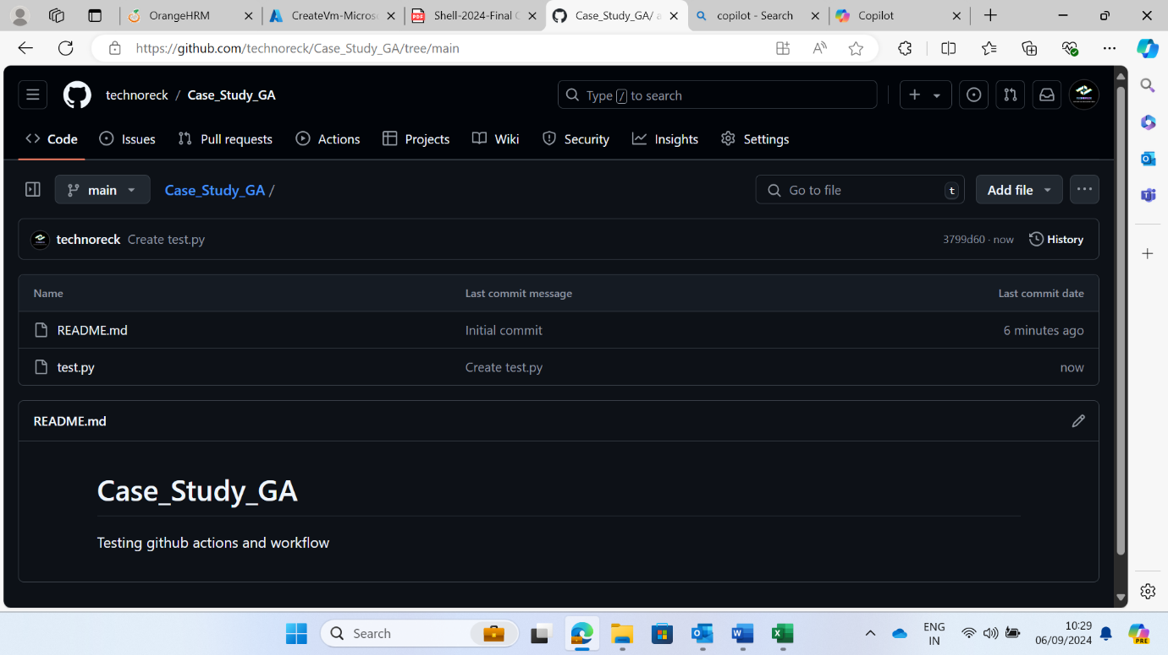

1. Going to GitHub actions and creating a custom workflow file main.yml.

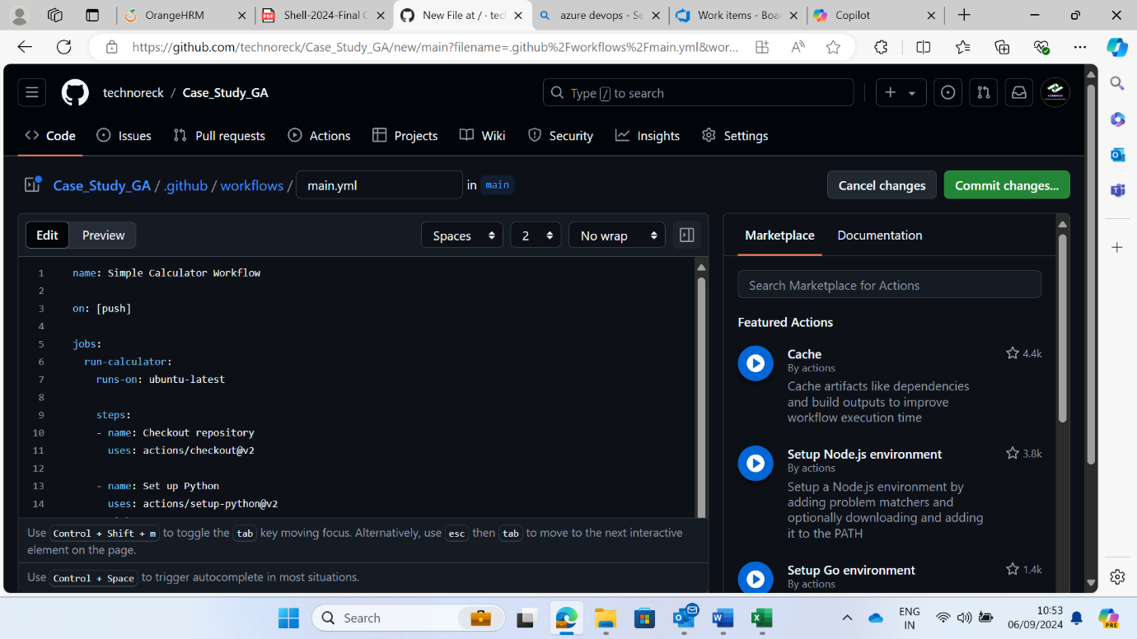

1. Running all the jobs in the workflow and manually checking the validity of runs.

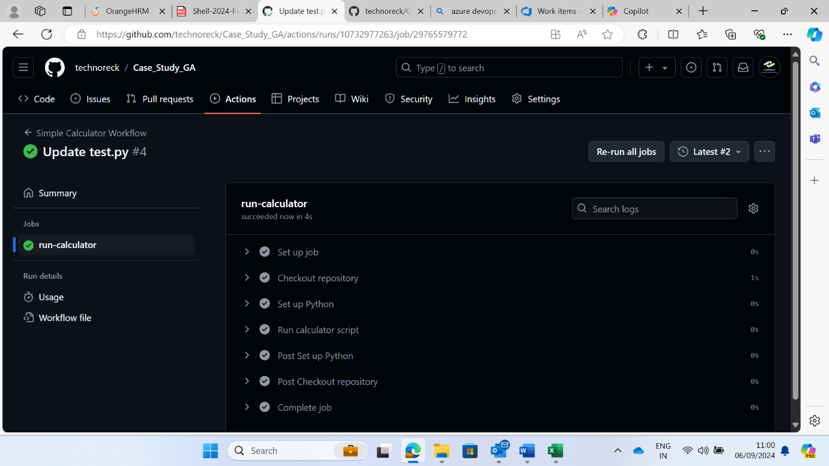

1. Adding new function to calculate power and committing it in the code.

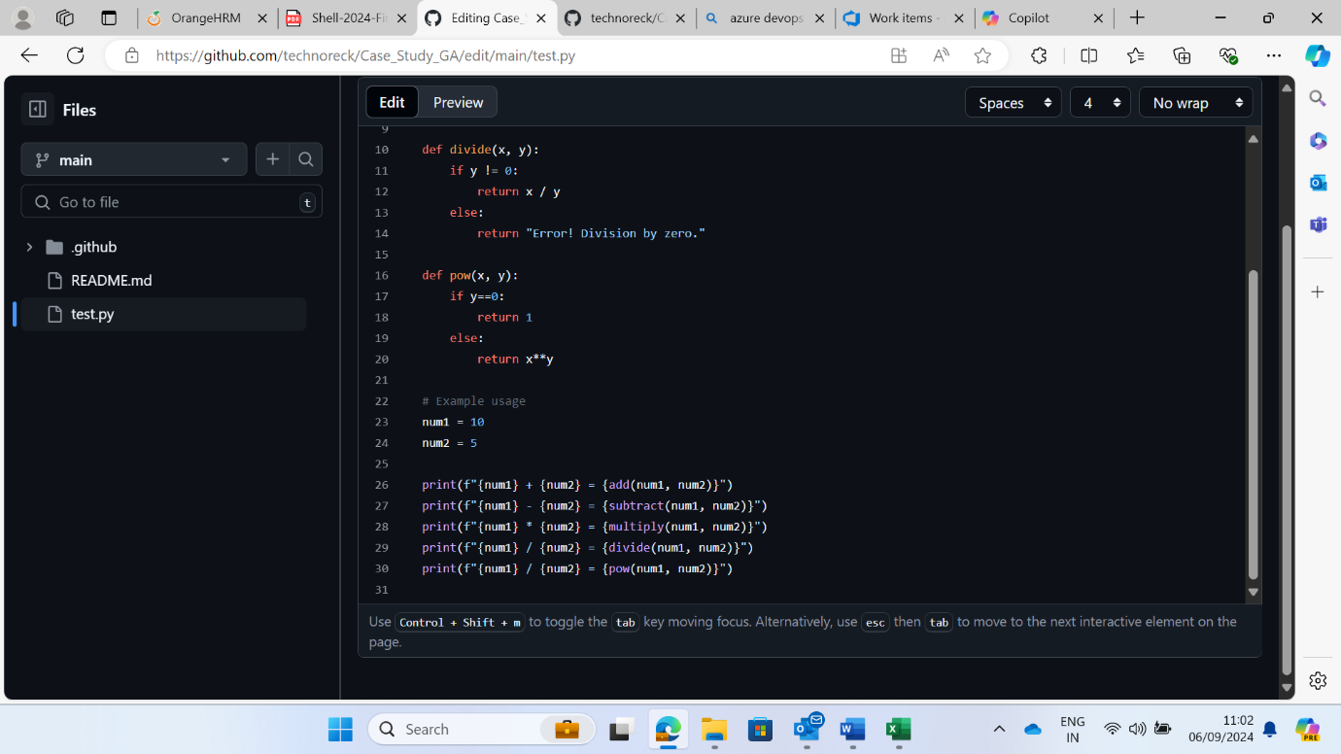

1. Re-running the workflow file after committing changes and manually verifying the validity of all jobs.

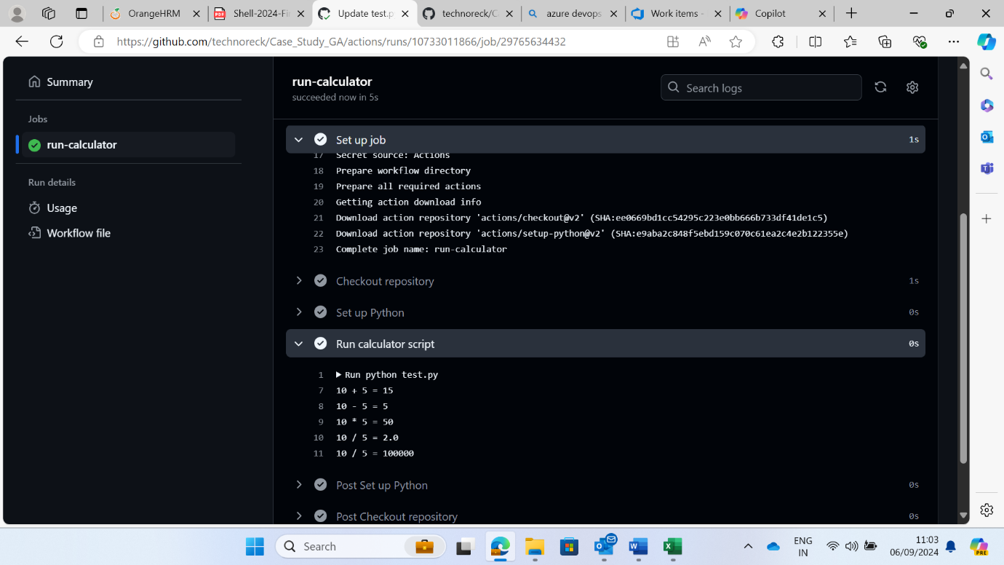

1. Completed the task

